|  |
| --- |
| ***Federated Insurance Companies*** |
| **Customer Relationship Management (CRM) Phase 1** |
|  |

# TABLE OF CONTENT

TABLE OF CONTENT 1

Description of customer\client: 2

System Request Form: 3

Results of Fact-Finding: 4

Project Scope Goal: 5

Project Scope Details: 5

Out of Scope: 6

Project Constrains: 6

Project Deliverables: 7

Project Schedule: 7

Feasibility Analysis: 7

Payback Analysis 7

Payback Analysis on Graph 8

Explanation 8

Tangible Benefits: 9

Intangible Benefits: 9

# Description of customer\client:

This project is catered to the Federated Insurance Marketing department. This department specializes in selling insurance policies to individuals and business owners such as business and/or property insurance. As quoted from the Federated Insurance’s website, they believe that their “…value is measured by the success of our clients. It’s our business to protect yours.” When creating the system, there will be many users that will use the system. These users are regional marketing manager (RMM), district marking manager (DMM), and Marketing representative (RM) and Home Office Marketers. Each of these users plays a big role in the company and in the system. The company’s biggest key factor that incentivizes businesses to switch to Federated Insurance is for their outstanding risk management coverage. They help businesses stay in business and that’s what any business’s main objective is.

# System Request Form:

**Personal Information: Date: 02/10/2018**

|  |  |
| --- | --- |
| **First Name**: Nicholas | **Last Name**: Wilson |
| **Department**: Marketing | **Employee ID**: 2390-1 |
| **Phone No**.: 507-351-**** | **Email**: nicholas.wilson@federated.org |

**Business Problem Statement:**

|  |
| --- |
| Federated Insurance, an insurance company which focus towards providing insurance to businesses and life insurance, currently do not have advance information management system. We are having problems to manage and keep track to our clients’ record resulting in extra time and labor to find required information. |

**High Level System Requirements:**

* Replace the old cumbersome technology
* Build a foundation for the master customer record, Customer Relation Management system (CRM).
* Support any future administrative changes.
* Minimize the risk Federated’s Customer Information Distribution System.
* Daily updates and changes in records to the CRM should be easy– CRM should be the primary system they will be in contact with every day at work.
* Abstracting any list, if within the authority, we need should be no time and labor consuming.
* Introduce Dashboard Capabilities.
* Encrypt the customer data – only the MRs could access the data only if those data are from their assigned territory.

**Priority Level:**

🞏 **Low** 🞏 **Medium** ⌧ **High**

**Time for Approval**

* 7 days

**Due On:** May 05, 2018



**For Department Use**

**Status:**

|  |  |
| --- | --- |
| ⌧ **Approved** | 🞏 **Declined** |



**Date: 02/25/18**

# Results of Fact-Finding:

Users of the system will have their own access to the system. RMMs have the highest access to the system. This allows them to fully access the system (read and write). The DMMs come in second having full access (read and write) to their designated districts. Third is are the Home Office Marketers, they will have access to the database just to read (not be able to write). Finally, the MRs, they can read, write and update his/her individual portal.

There are two types of clients that Federated Insurance have labeled Insured and not insured. As the names of the labels apply, insured are people that are in the federated database as individuals/business that are currently under an insurance policy while not insured refers to individuals or businesses that are not covered by a Federated Insurance policy.

Federated Insurance labels their customers and potential customers. These labels are put in place to reflect each person/business status within the company’s standards. The labels are as follows: insured, Prospect, Uninsurable, Top 100, and Top Prospects. Other than insured, The Top Prospects are the ones that are the closest to being insured. The marketing team has a high interest in these individuals/businesses. This means that the marketers need to find out information about their potential client. Information such as family members, birthdays, anniversaries, etc. This shows clients that Federated Insurance really care about them and their business. While some businesses are passed down from generation to generation. It is important to find out who will be the new owner of the company once the current owner retires.

Some important things that are needed to be implemented into this system. Every MR will have their own territory for which they are assigned (1:1 MR to Territory ratio). Information such as company name, current policy (if possible), email address, telephone numbers and a way to take notes about phone calls should be implemented into the system. This such as scheduling feature, reminders and birthday tacking are also important (notifications should be 3 months, 2 months, and 1 month prior to policy expiration date). Making the system mobile friendly is also a must.

# Project Scope Goal:

* This project will develop a new application system for Federated Insurance. In this application system, the user will be able to connect to a database and view clients’ information’s, schedule appointments, get alerts on several things, write general notes all while being integrated with Microsoft outlook.

# Project Scope Details:

* Build a dashboard which gives an overview of all the important details such as gauge indicator which shows the MRs long/short term goals, events coming soon, reminders (reminders for scheduled key meetings flagged in the calendar, policy expiration date so the MR can send an email to the customer to request a meeting to discuss about renewing the policy).
* Build a foundation for the master customer record.
  1. Should work for prospects and insureds.
  2. Should have customer type field (prospects or insureds) to use it later to add more fields related to the prospects or insureds only.
  3. Insured customers should have fields for the four pre-flagged annual meetings which are:
     1. Risk control review.
     2. Financial protection review (how much money left in the policy).
     3. Annual client review (for any change in their industry specialty).
     4. Client map review.
* Have the ability in the system to prioritize your customers and group them as:
  1. Insured customers the MR interested to offer them a policy again after their current policy expires due to the safe practices that happens at their businesses (based on the four annual meetings outcomes)
  2. Insured customers the MR not interested to offer them a policy again after their current policy expires due to the risky practices that happens at their businesses (based on the four annual meetings outcomes)
  3. Prospective customers the MR interested to offer their business a policy due to the notes that had been taken about them either directly through face-to-face meeting or through the MR investigations.
  4. Prospective customers the MR not interested to offer them a policy due to the notes that had been taken about their business either directly through face-to-face meeting or through the MR investigations (basically because of the huge amount of the risky practices that happens at their businesses
* Build a functionality in the system to allow the MRs, DMMs, RMMs to generate different reports such as financial analysis report, and Client statistic report (see Fact-findings file for more details).
* The security levels are as follow:
  1. Regional Marketing Manager: [Full access (read and write only within assigned region)]
  2. District marketing manager: [Full access (read and write only within assigned district]
  3. Home office Marketing: [Limited access (read only within assigned territory)]
  4. Marketing Representative: [Full access (read, write only within assigned territory)]

# Out of Scope:

* Outlook integration for the calendar and the emails.
* Auto send master emails and notices that the Policy management department able to set to his current insureds such as bill reminder notice.
* Life insurance policies.

# Project Constrains:

* The system application must be available for all devices to meet the requirements of the system being mobility friendly.
* The given time frame to complete this project is 2.5 months.

# Project Deliverables:

* Requirements
* Design specifications
* Prototype of the CRM system and its different functionalities.
* Architecture design document.
* Deployment plan
* Training materials

# Project Schedule:

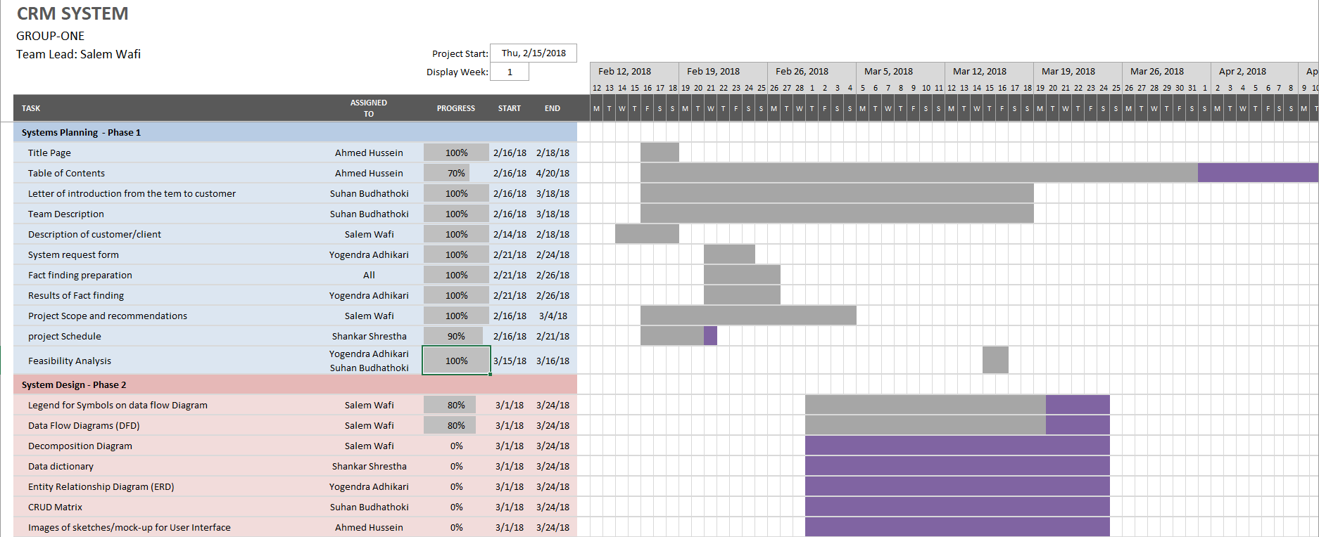

# Feasibility Analysis:

## Payback Analysis

|  |  |  |  |  |
| --- | --- | --- | --- | --- |
|  | **Costs** | **Cumulative Costs** | **Benefits** | **Cumulative Benefits** |
| 0 | 30,000 | 30,000 | 3,500 | 3,500 |
| 1 | 10,000 | 40,000 | 15,000 | 18,500 |
| 2 | 11,100 | 51,100 | 21,000 | 39,500 |
| 3 | 12,200 | 63,300 | 28,000 | 67,500 |
| 4 | 12,800 | 76,100 | 32,000 | 99,500 |
| 5 | 14,300 | 90,400 | 40,500 | 140,000 |
| 6 | 15,000 | 105,400 | 45,600 | 185,600 |
| 7 | 15,400 | 120,800 | 51,200 | 236,800 |
| 8 | 16,200 | 137,000 | 57,000 | 293,800 |
| 9 | 16,500 | 153,500 | 65,000 | 358,800 |

## Payback Analysis on Graph

## Explanation

The rough estimation of the development of CRM system is $30,000— therefore, the cost of the system is same for the year 0; which is described to be the year when the system is developed. The cost of the system doesn’t stop there, it needs to go through annual checkup and upgrade if something needs changes. After year 0 the actual benefit starts to grow and after some time, the total benefit surpasses the total expenses for the system, hence the time needed for a system to pay the total cost of itself is **payback period.** In the payback analysis chart above, the payback period is near to year 3. If we look over the analysis table, in year 3 the cumulative cost of the system reaches $63,300 whereas the cumulative benefit has already reached $67,500. Thus, before the beginning of the fourth year of the system, the total benefit yielded by the system surpasses the total cost of itself. After that period, the benefits keep growing constantly for certain time. After a certain time, the system’s economically useful life will be over and then the cost of maintaining the system will start to increase and benefit will decrease. This is where the system will need a massive upgrade or a whole new system will be needed.

Hence, from the analysis we can say the total estimated cost of the system is $63,300 which is covered within 3rd year of the system development.

## Tangible Benefits:

* *Production Increase*

According to the project scope, the application will have a dashboard which shows all the important details for the representative. If it is easier for the employee to get all the notifications and important tasks as soon as they open the application, the productivity of the company is bound to increase.

* *Staffing Reduction*

The application will work as a personal assistant for all the representatives including the higher ranked professionals. The project application will be the only application required for the representatives to kickstart their tasks without any external help. After the completion of project, the cost of staff could be reduced which will be a positive point in cost-analysis.

## Intangible Benefits:

* *Efficiency*

The employees will be able to work solely and all the details that they need will be within a few clicks. If everything an employee requires is right in front of them, the efficiency of work is bound to increase. Thus, the project is bound to increase the efficiency of production.

* *Client/Customer Satisfaction*

Customer satisfaction is the main point in one of the intangible benefits of the project. Since the employee will have all the reminders in their dashboard, including customer reminders, they are certainly closer to the customers. If the customers are approached in a timely manner to the notifications, they would be convinced to increase terms with the company.